# Probability

**Probability:**  the likelihood of an event occurring

The probability of an event must be in between 0 and 1

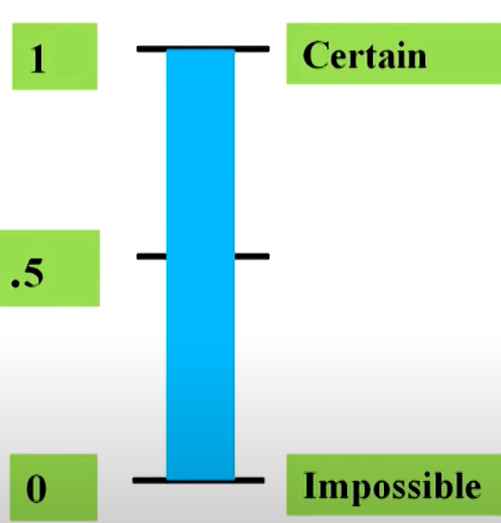

**1. Experiment**

An **experiment** is any process that gives some outcomes.  
👉 **Example:** Rolling a die is an experiment because we get a number between 1 and 6.

**2. Sample Space (S)**

The **sample space** is the set of all possible outcomes of an experiment.  
👉 **Example:** When rolling a die, the sample space is:

S={1,2,3,4,5,6}

**3. Elementary Events**

An **elementary event** is an event that contains only **one** outcome.  
👉 **Example:** Getting a 3 when rolling a die is an elementary event:

E={3}

**4. Event**

An **event** is any collection of one or more outcomes from the sample space.  
👉 **Example:** Getting an **even number** when rolling a die is an event:

E={2,4,6}

**5. Union of Events (A∪B)**

The **union** of two events means **either one or both** of them happen.  
👉 **Example:**

* Event A: Getting an even number {2,4,6}
* Event B: Getting a number greater than 4 {5,6}
* A∪B = {2,4,5,6} (Numbers that are in either A or B or both)

**6. Intersection of Events (A∩B)**

The **intersection** of two events means both events happen **together**.  
👉 **Example:**

* A∩B={6} (Only 6 is both even and greater than 4)

**7. Mutually Exclusive Events**

Two events are **mutually exclusive** if they **cannot** happen at the same time.

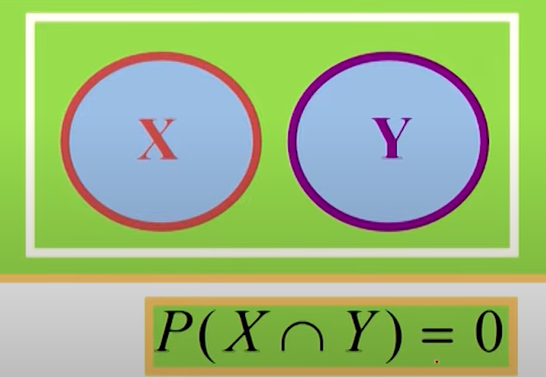  
👉 **Example:**

* A= Getting an even number {2,4,6}
* C= Getting an odd number {1,3,5}
* A∩C=∅ (No common outcome)  
  🔹 **Conclusion:** You **cannot** get both an even and an odd number at the same time!

**8. Independent Events**

Two events are **independent** if the outcome of one does **not** affect the other.  
👉 **Example:** Rolling a die **and** flipping a coin are independent because rolling a die does not change the probability of getting heads.

**9. Collectively Exhaustive Events**

A set of events is **collectively exhaustive** if **at least one of them must happen**.  
👉 **Example:**

* A= Getting an even number {2,4,6}
* C= Getting an odd number {1,3,5}  
  🔹 These two events together **cover all possible outcomes** {1,2,3,4,5,6}so they are **collectively exhaustive**.

**10. Complementary Events**

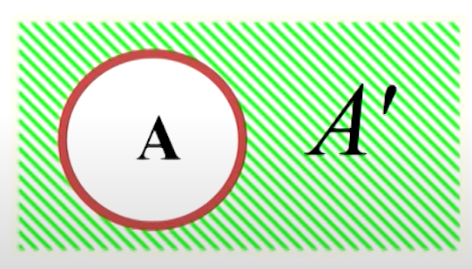

The **complement** of an event A is everything **not in A**.  
👉 **Example:**

* A= Getting a number less than 4 {1,2,3}
* **Complement of A (Ac)** = Getting a number 4 or more {4,5,6}  
  🔹 **Conclusion:** Either you get a number **less than 4** or **4 or more**—no other possibility!

## Methods of assigning probabilities

1. Classical method of assigning probabilities (rules and laws)
2. Relative frequency of occurrence (cumulated historical data)
3. Subjective Probability (personal intuition or reasoning)
4. Classical probability:

Used when all outcomes are **equally likely**.

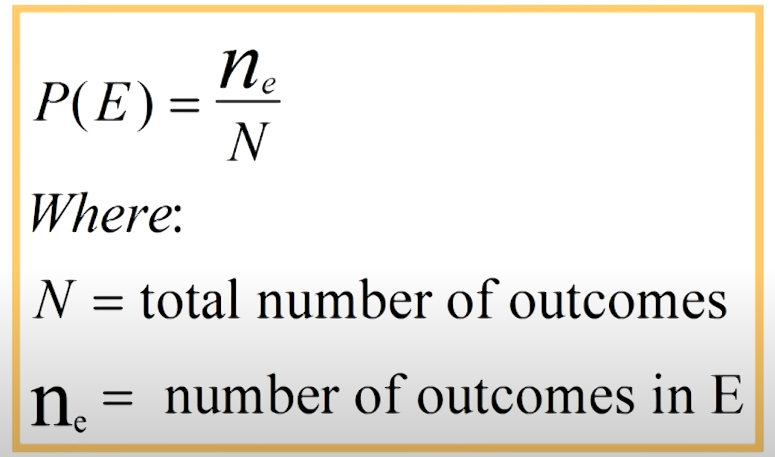

1. Relative frequency: Same formula like above.

Based on **experiments or past data**.

1. Subjective probability:

Based on **personal judgment or belief**, not on exact calculations or experiments.

## Methods for describing a sample space

1. **Roster or Listing**

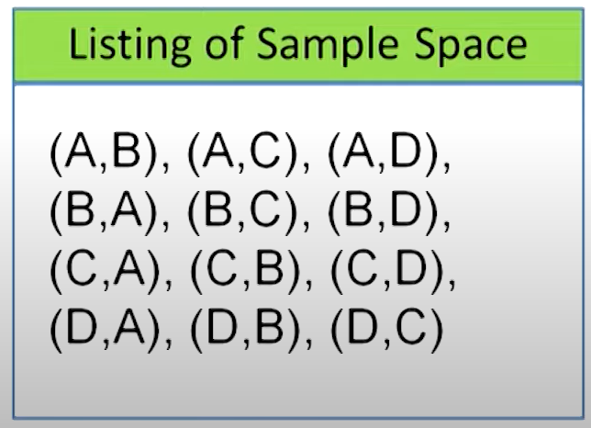

**2. Tree Diagram**

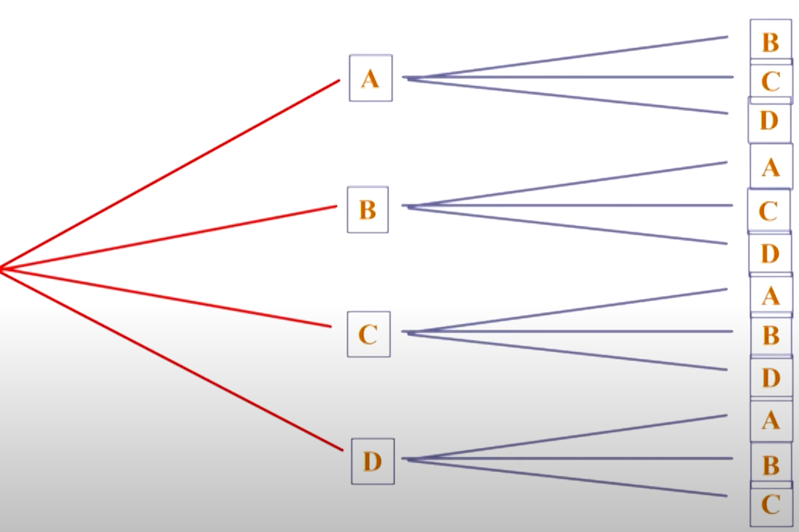

**3. Set Builder Notation: S={x,y |}**

**4. Venn Diagram**

## Counting the possibilities

### **1. Multiplication Principle (Mn Rule)**

The **Multiplication Rule (Mn Rule)** states that if an experiment consists of **multiple independent staes**, where:

### 2. Sampling from a Population

When selecting items from a group (population), there are two main ways to sample:

* 1. **Sampling With Replacement**
* **Definition:** After selecting an item, you put it back into the population before selecting again.

**Example:**

* Suppose you have a jar with 5 colored balls (Red, Blue, Green, Yellow, White).
* If you pick a ball, note its color, and **put it back**, the next selection still has **5 balls to choose from**.
* If you pick 3 times, the number of ways = 5×5×5=1255 \times 5 \times 5 = 1255×5×5=125.
  1. **Sampling Without Replacement(Combinations)**
* **Definition:** After selecting an item, you do not put it back into the population.

**Example:**

* Suppose you have a deck of 52 playing cards.
* If you draw a card and do **not** return it, the next draw will have **only 51** cards left.
* If you pick 3 times, the number of ways = 52×51×5052 \times 51 \times 5052×51×50.
* 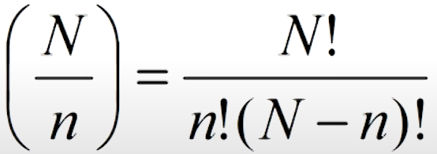

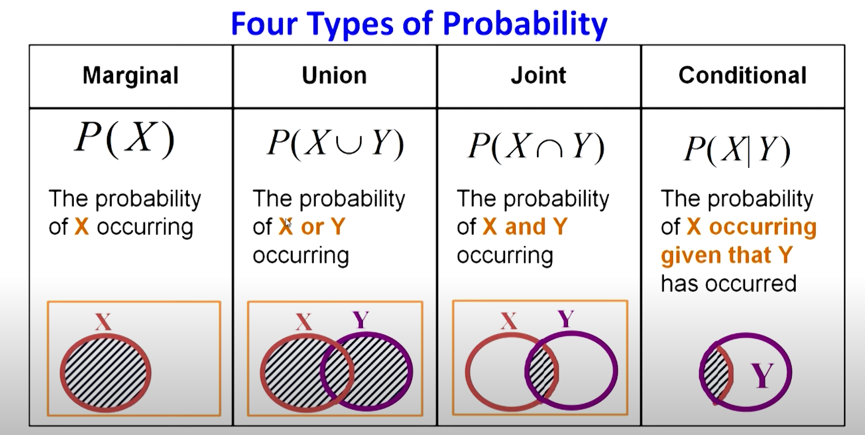

## Addition Law

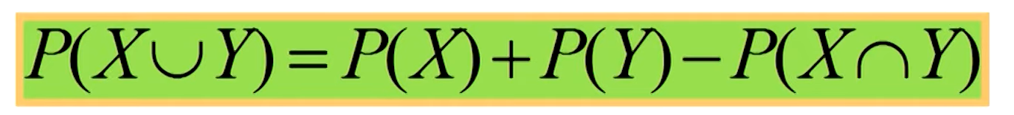

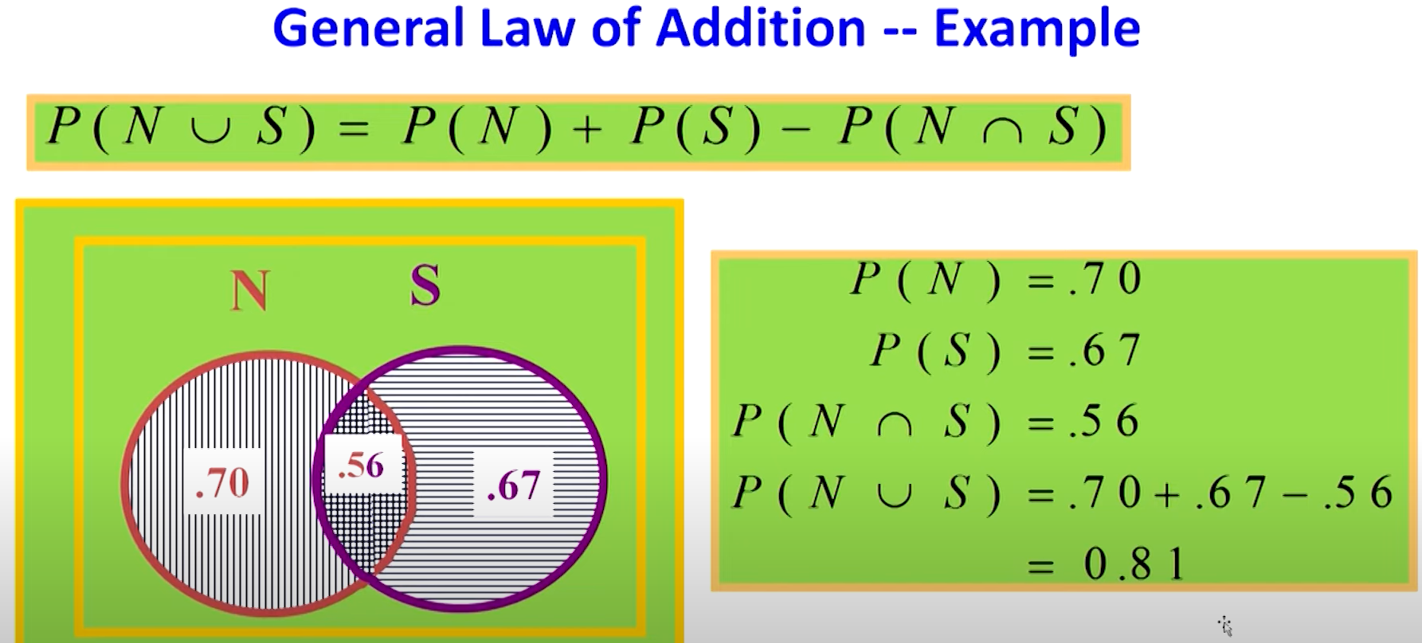

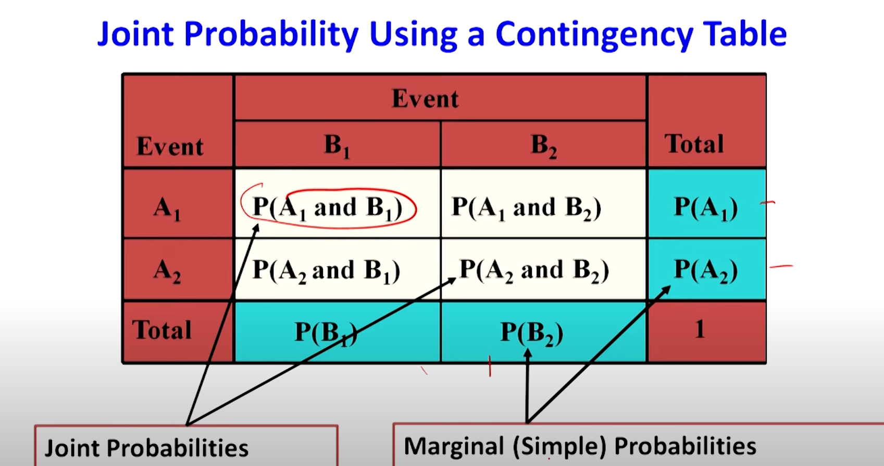

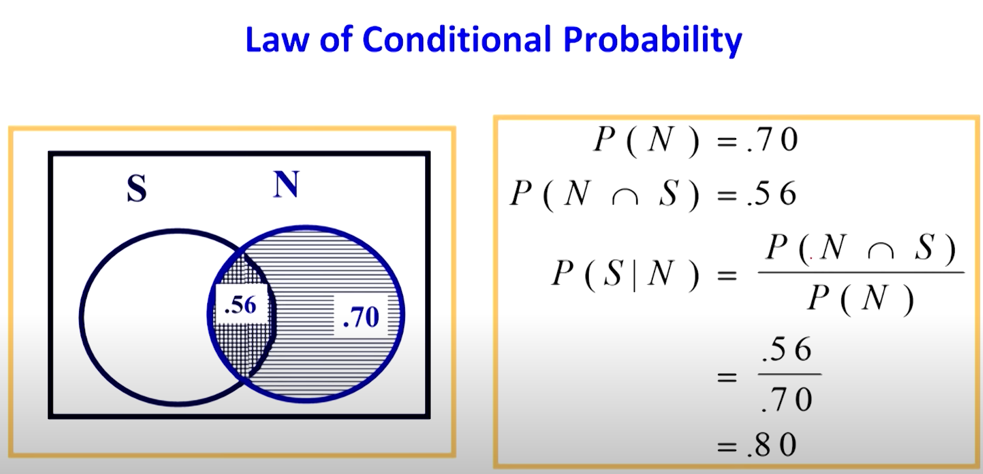

**1. Raw Values Matrix**

A **raw values matrix** is a table that contains the actual collected data in its original form, without any processing or summarization

**2. Contingency Matrix (Contingency Table)**

A **contingency matrix** (or **contingency table**) is a table used in statistics to show the **frequency of occurrence** of different categories in two or more variables. It is commonly used in **categorical data analysis**.

### Law of Multiplication

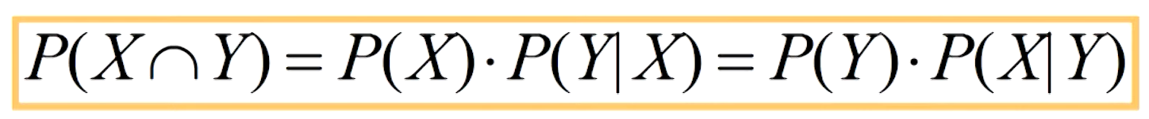

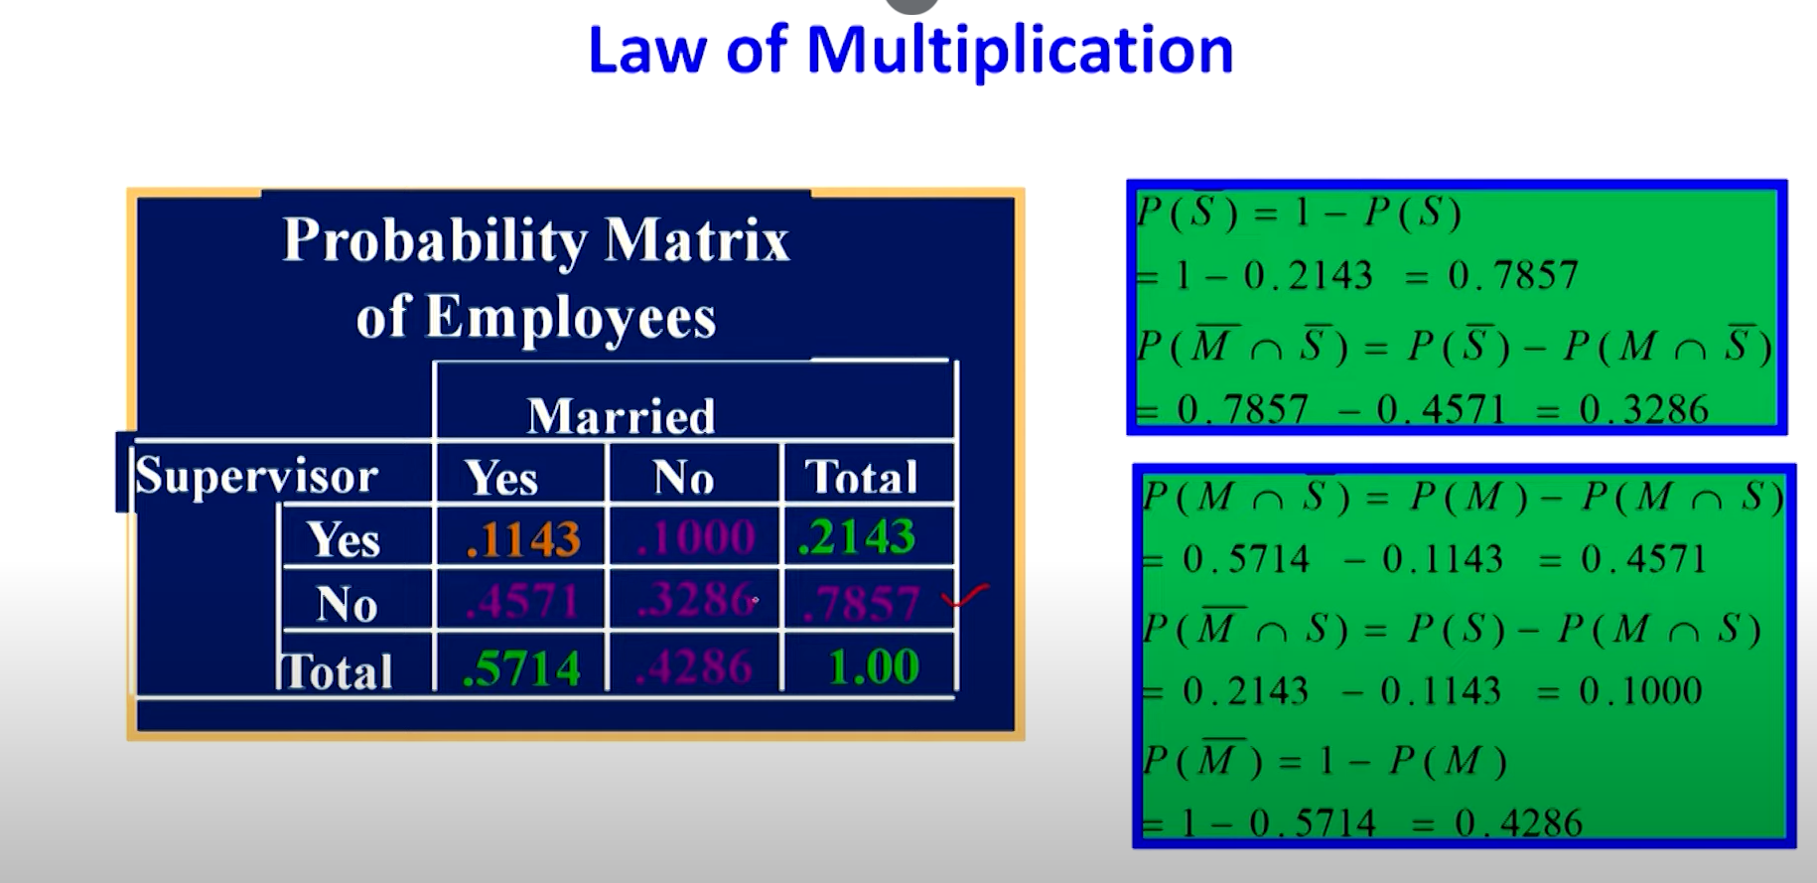

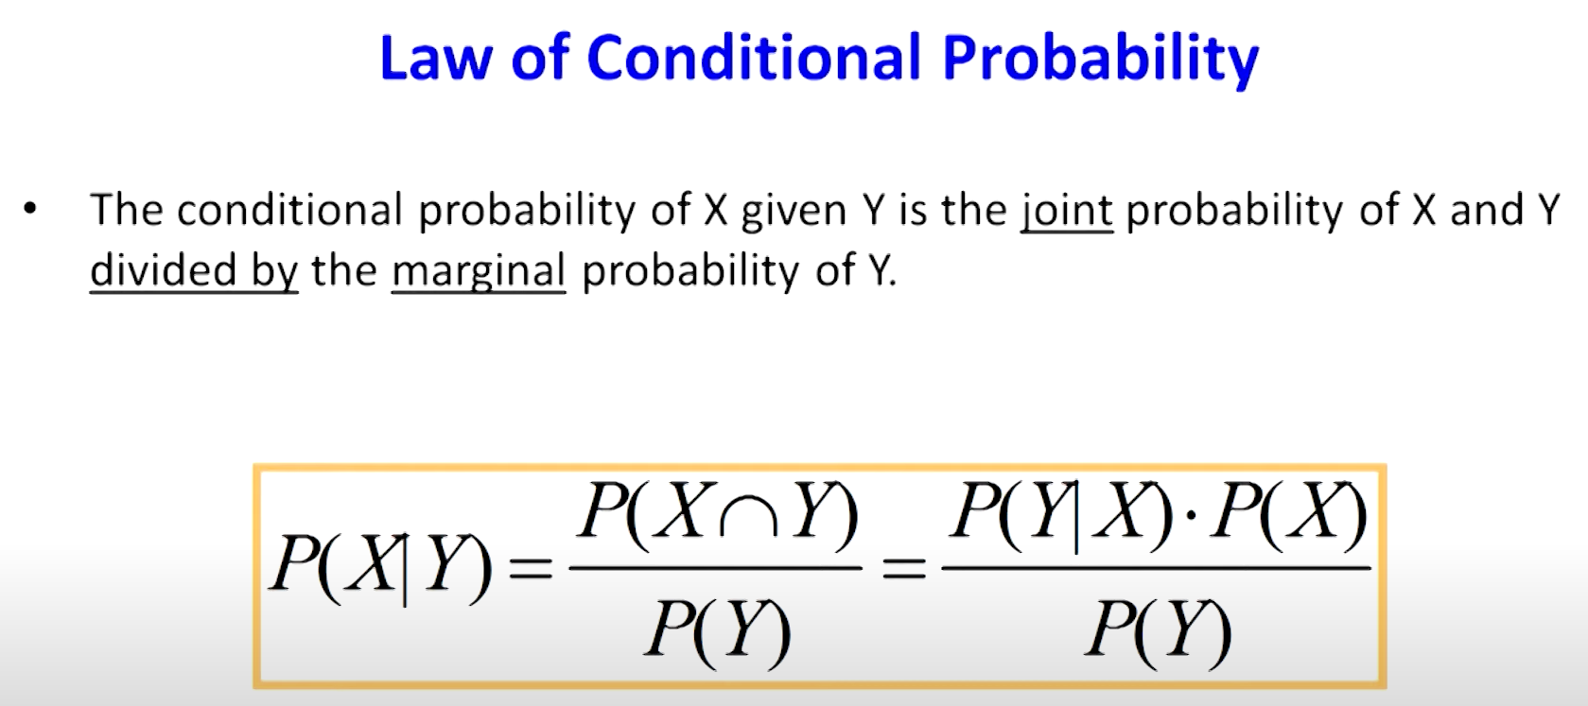

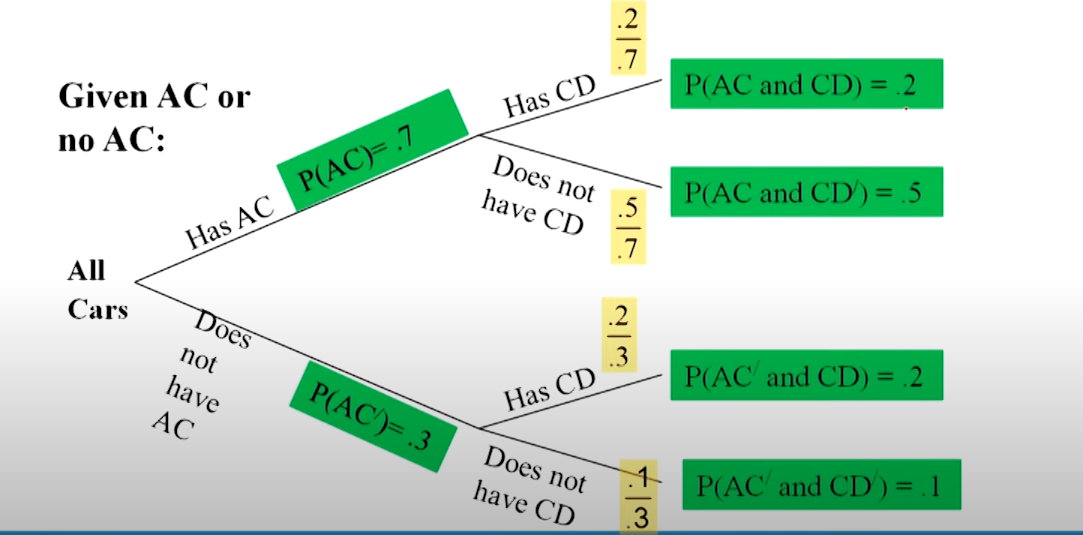

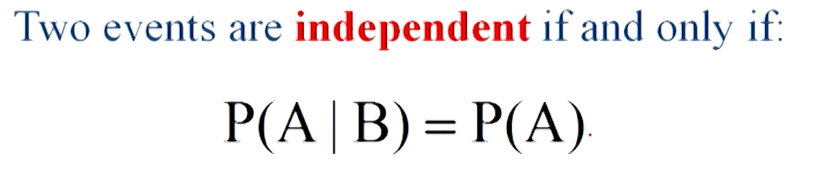

## Bayes Theorem (bayes’ Rule)

An extension to the conditional probability, it is like a revision of probabilities

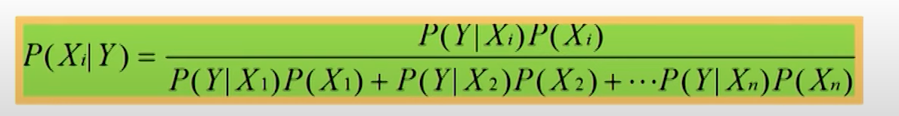

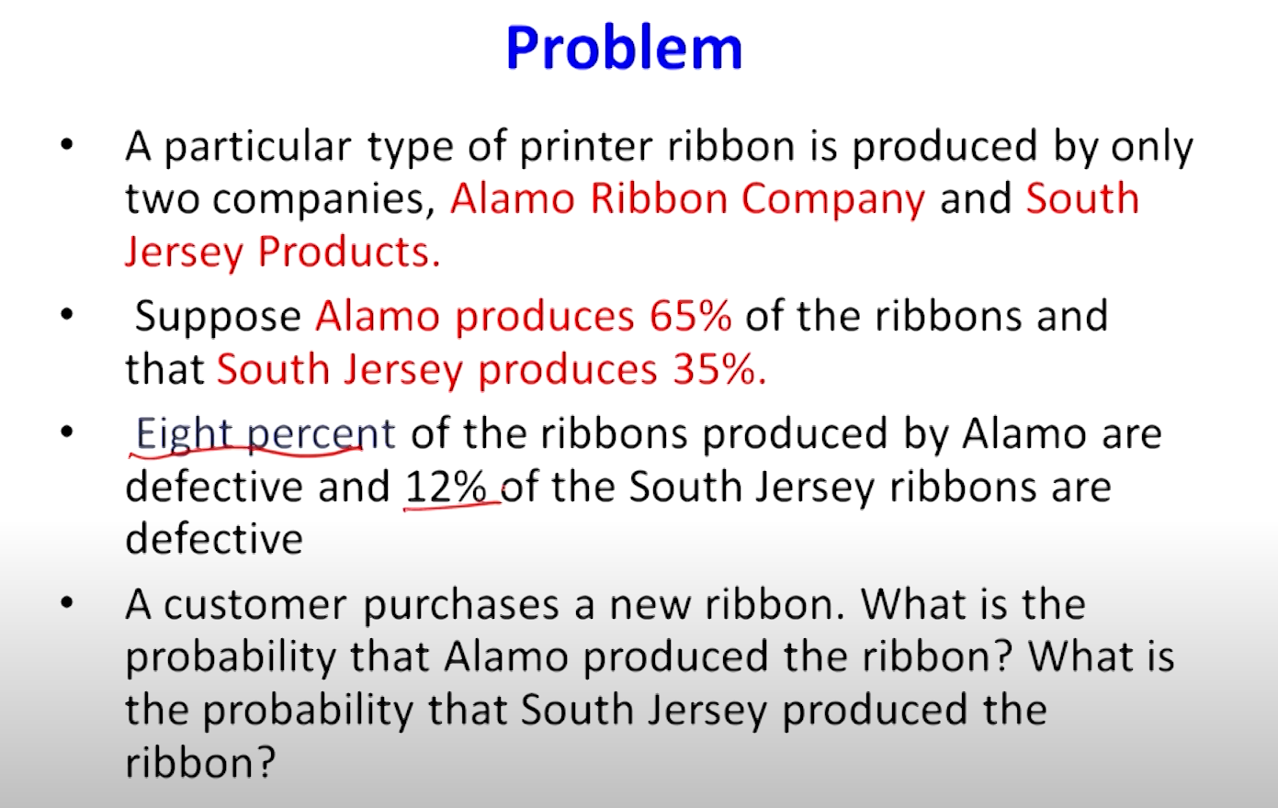

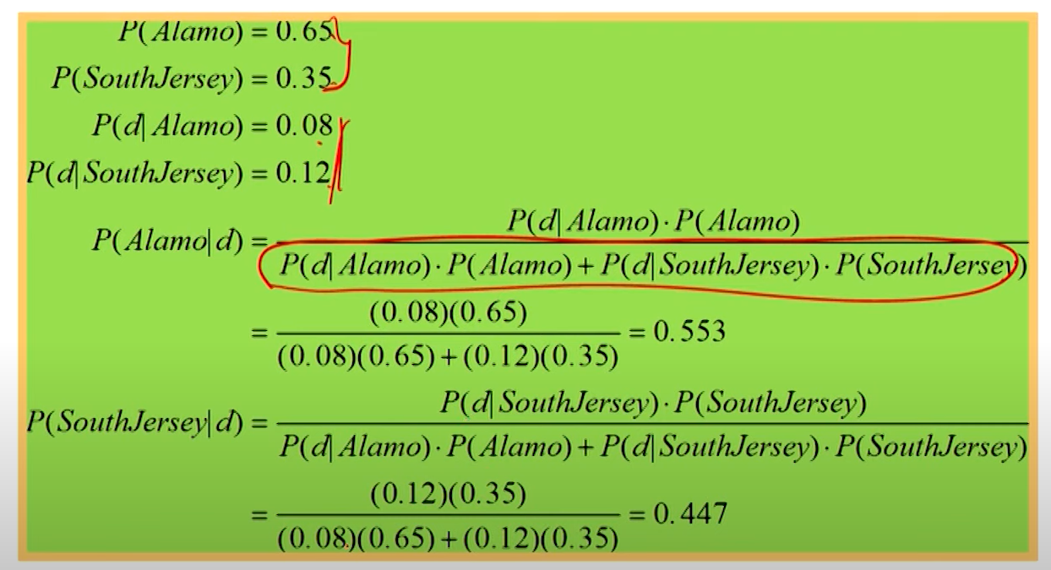

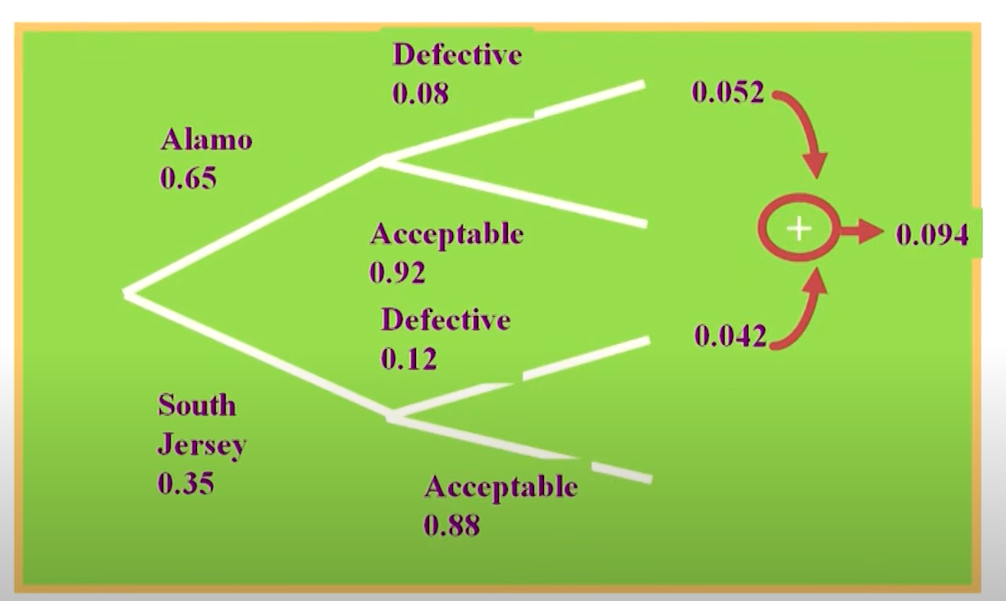

# Combinatorics (Permutations & Combinations)

## Permutations:- {Apple, Banana} =/ {Banana, Apple}

## Combinations:- {Apple, Banana} == {banana, Apple}

# Distributions

* + - * Shape of set of numbers

**Random variable**: A **random variable** is a variable that takes on numerical values based on the outcome of a random experiment.

* + - * Discreate: Takes on a countable number of values (e.g., integers).
      * Continuous: Takes on an uncountable number of values (e.g., real numbers).

### **Probability Distribution**

A **probability distribution** describes how probabilities are assigned to different possible outcomes of a random variable. It gives insights into the likelihood of each outcome occurring

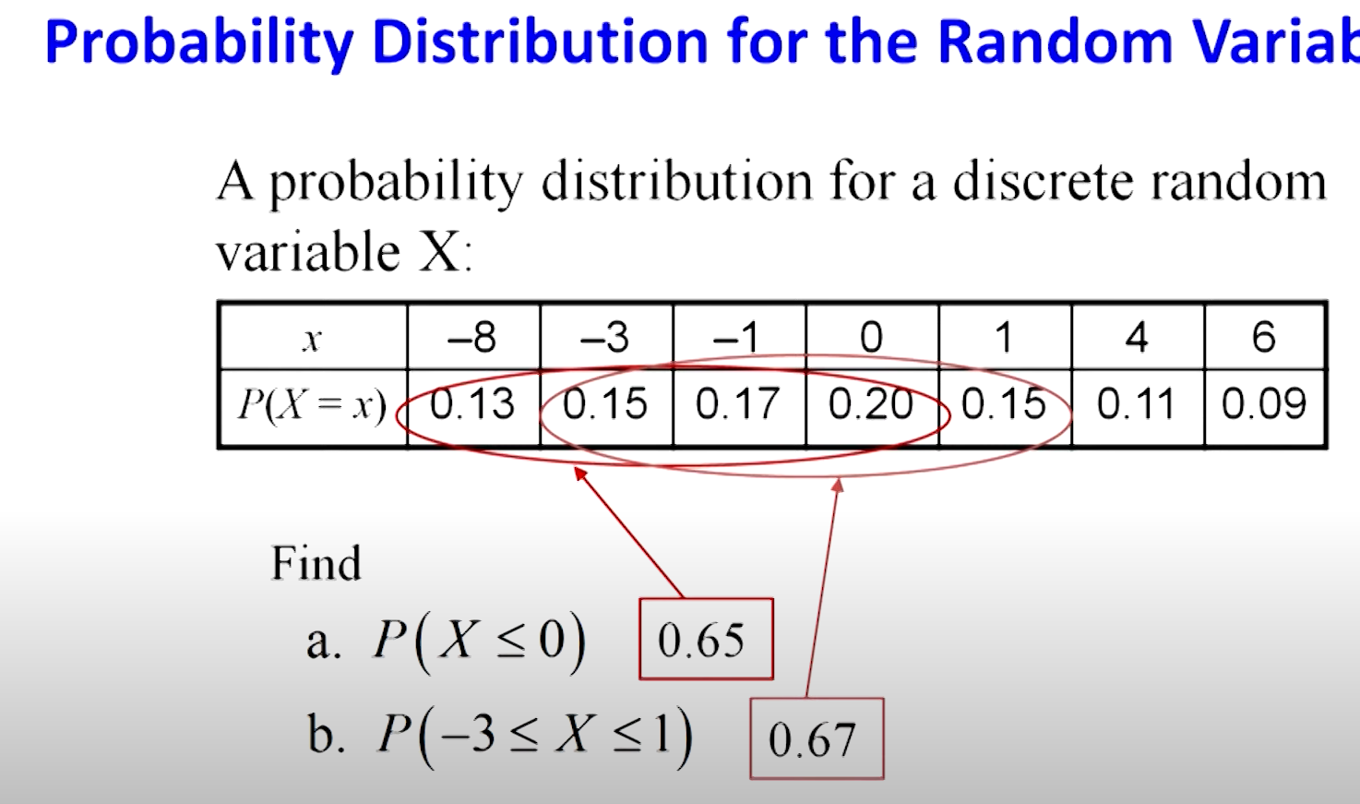

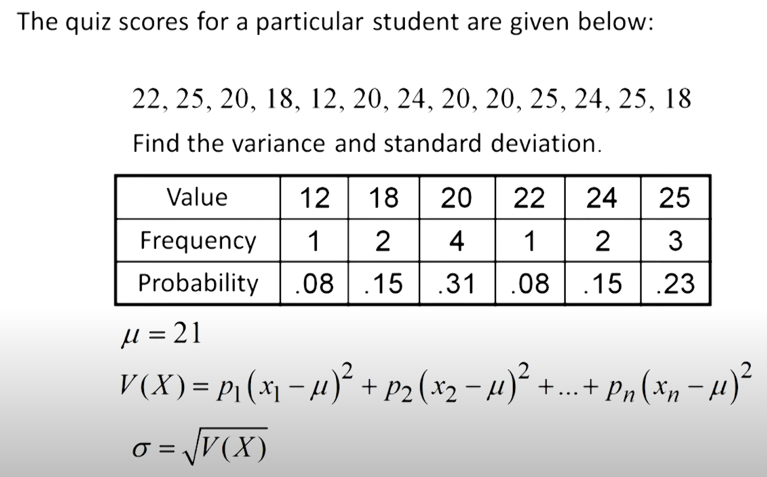

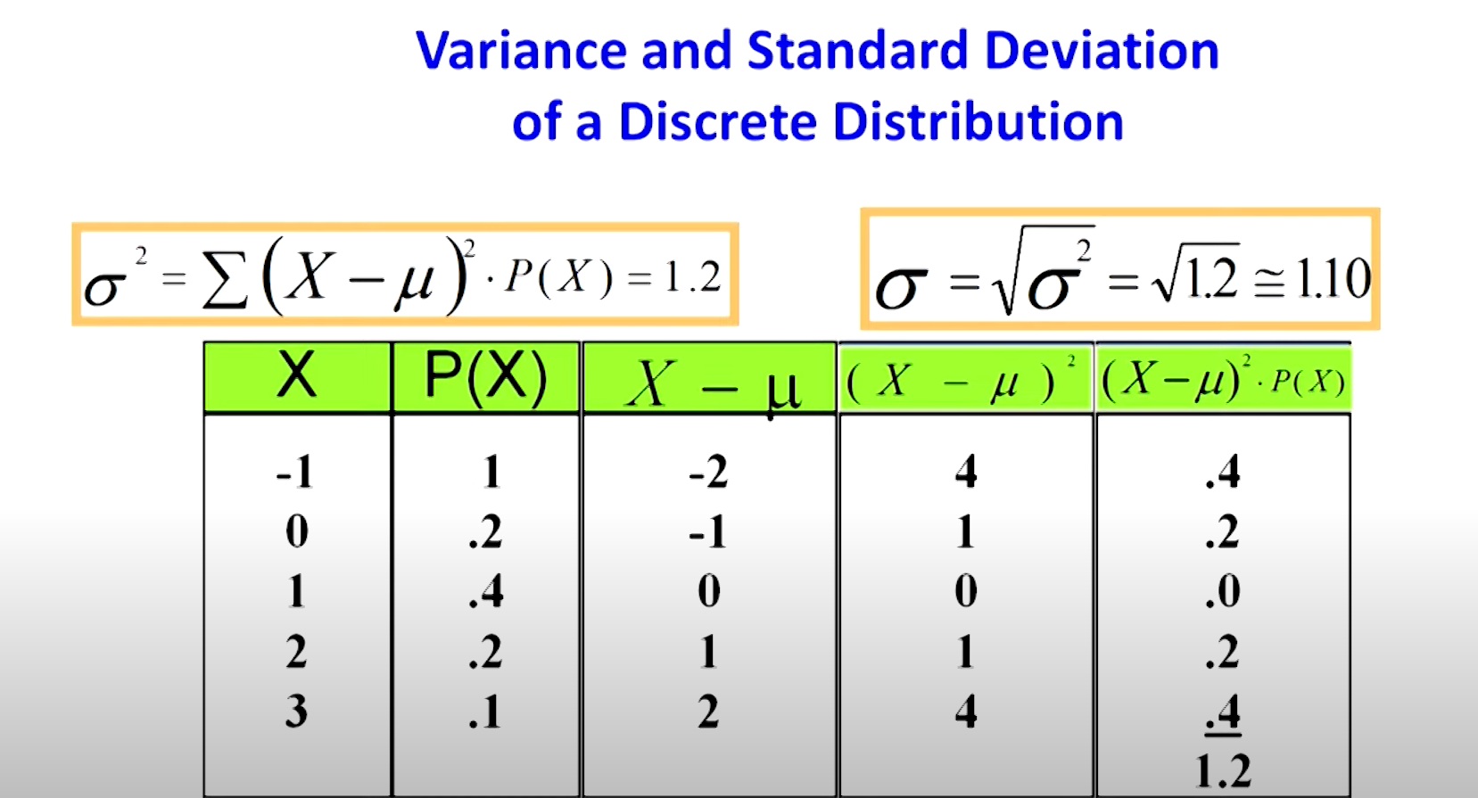

Some special distributions

1. Discrete:
   1. Binomial
   2. Poisson
   3. Hyper geometric
2. Continuous:
   1. Uniform
   2. Exponential
   3. Normal

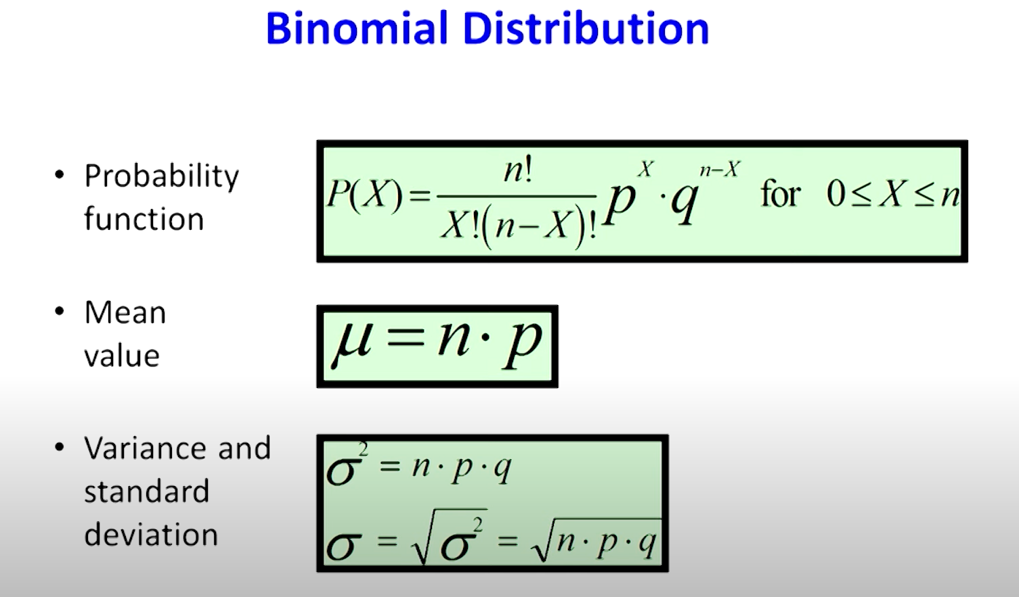

**Poisson Distribution t**

The **Poisson Distribution** is a probability distribution that models the **number of times an event occurs in a fixed interval of time or space**, given that the events occur independently and at a constant average rate.

It is useful when dealing with rare or random events that happen over **time, distance, area, or volume**.

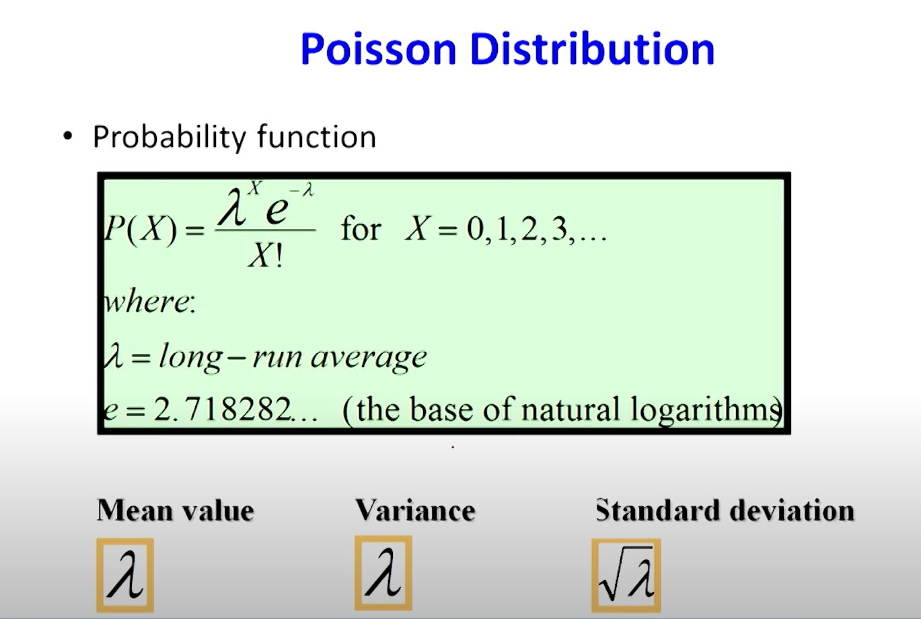

**Hypergeometric Distribution**

The **Hypergeometric Distribution** is a probability distribution that describes the **number of successes in a fixed number of draws from a finite population, without replacement.**

